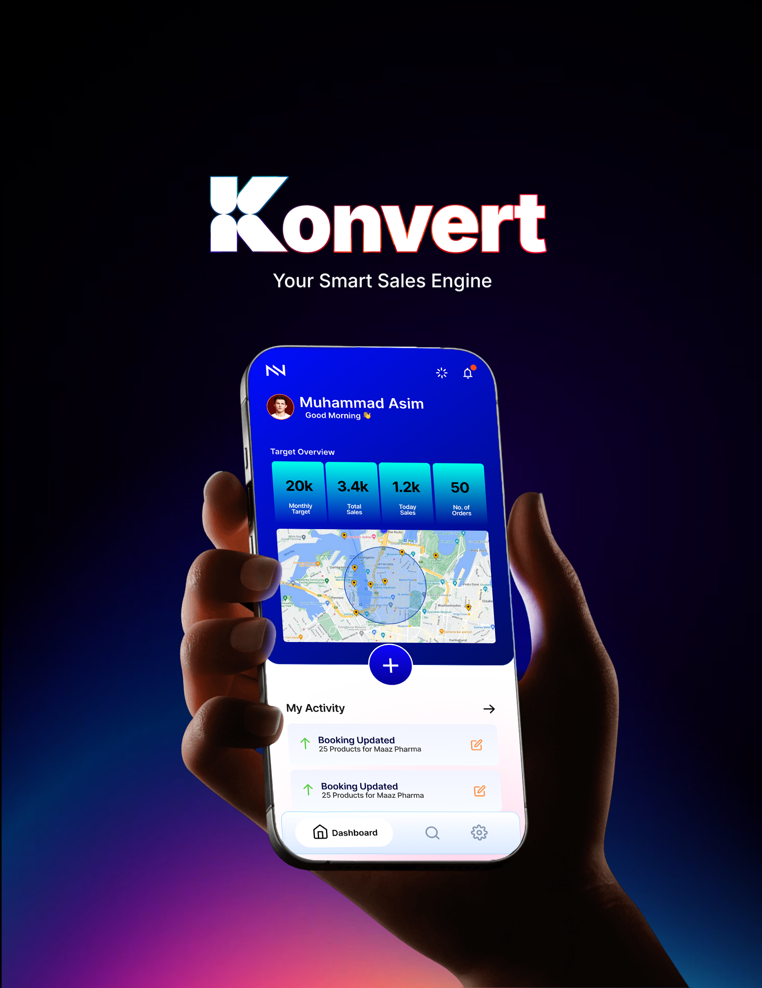

SECTION 01
The Problem We Are Solving

A company's sales plan and the real work happening in the field are often two different things.
Every pharma company makes a sales plan. It shows which doctors to visit, how often, and what targets to hit. But the actual work in the field is often different from the plan. A representative decides who to visit that day. At night, he writes down what happened, from memory. Samples are handed out, but often nobody records it anywhere. This gap between the plan and the real work costs money. Field staff is one of the biggest costs for a pharma company. Yet most companies cannot clearly see what their field staff are doing each day.
This app is built to close that gap. It connects representatives, area managers, regional managers, and head office in one system. When a rep visits a doctor, that visit shows up on a manager's screen within a few minutes. There is no need for phone calls or spreadsheets at the end of the day to find out what happened in the field.

How the Parts Connect
Mobile App (Field) | → | Sync Engine | → | Cloud Server | → | Web Admin Panel

A Few Numbers
5–7 days  APP WORKS WITHOUT INTERNET | Under 2 min  TIME TO LOG ONE VISIT | Few minutes  FOR DATA TO REACH HEAD OFFICE

SECTION 02
Other Options in the Market

Pharma companies in Pakistan usually consider two kinds of systems. Neither one is a good fit for most companies.
Option A — Large International Systems
Systems such as Veeva, IQVIA, and Salesforce are strong products. But they are built for large multinational companies. They are priced in US dollars, per user. Setting them up can take many months. For a mid-size Pakistani company, this is usually too expensive and too complicated.
Option B — Older Local Systems
Local systems usually cost less. But many are difficult to use, and representatives often stop using them properly after a few weeks. More importantly, most of these systems cannot stop a rep from faking their GPS location. A free app can be used to show a fake location. If this happens, the company cannot fully trust the data it is collecting. And if the data cannot be trusted, the system is not doing its job.
What We Are Offering
This app matches the features of the better regional systems already used in South Asia. It also does two things that most other systems in Pakistan do not do well: it stops fake GPS locations, and it keeps working fully even without internet for several days at a time.

A Side-by-Side Comparison
WHAT MATTERS | LARGE INTERNATIONAL SYSTEMS | OLDER LOCAL SYSTEMS | THIS APP
Cost | Very high, paid in US dollars | Low at first, but problems appear later | Reasonable cost, in Pakistani rupees
Works without internet | Needs a stable internet connection | Often does not work well without signal | Works fully for 5 to 7 days offline
Stops fake GPS locations | Basic checks only | Very weak — easy to trick | Several checks used together
Sample record-keeping (DRAP) | Available, but takes work to set up | Usually done by hand, on paper | Built into the app, updates in real time
Tax invoicing (FBR) | Needs extra setup work | Usually not included | Built into the app
Easy for reps to use daily | Takes time to learn | Simple, but feels old and slow | Built to be fast for daily field use

SECTION 03
What the App Does

The app has ten main parts. They all work together as one system. For each part below, we explain what it does, how it works step by step, and why it is useful.

01 Company Structure and Territories
Every company has its own reporting structure — representatives, area managers, regional managers, and head office. This app lets you set up your exact structure. You do not need to change how your company is organised to fit the app.

Head office sets up reporting lines | → | Rules are sent to every phone | → | Staff changes are handled without losing old records

WHY IT MATTERS
When a staff member changes roles or leaves the company, no history is lost. Each manager only sees data for his own team. This is checked by the server, not only by the app on the phone, so it cannot be bypassed.

✎ DESIGN NOTE
A simple chart, like a family tree. National manager at the top, then regional managers, then area managers, then representatives. Each box shows how many people report to that person.

02 Doctor and Chemist Records
This is one shared list of every doctor, chemist, and distributor. When a new record is added, the system checks if it is a duplicate, so the same doctor does not get added twice under two different names.

Rep adds a new doctor | → | System checks for duplicates | → | Manager approves | → | Added to the shared list

WHY IT MATTERS
A clean, accurate list means every report built on top of it is also accurate. Without this check, companies often end up with messy, duplicate records that are hard to fix later.

✎ DESIGN NOTE
A doctor's profile screen. It shows the doctor's name, a photo space, a grade (A, B, or C based on potential), and the doctor's location on a small map.

03 Monthly Visit Planning
The system builds each representative's monthly visit calendar on its own. It makes sure important doctors are visited often enough. If a plan does not meet the minimum number of visits required, the system will not accept it until the issue is fixed.

Calendar is built automatically | → | Rep reviews and adjusts it | → | Manager approves | → | Daily plan appears on the rep's phone

WHY IT MATTERS
Representatives spend less time on easy, low-value visits. Important doctors always get the number of visits they need, every month.

✎ DESIGN NOTE
A calendar for one month. Each day shows a colour dot: green means the plan was completed, yellow means partly completed, grey means a day off. A score at the top shows how much of the month's plan was completed.

04 Fast Visit Logging (Daily Call Report)
This is the screen representatives use the most. A rep can record a full visit — location checked, products discussed, samples given — in under two minutes.

Rep taps “Start Visit” — location checked | → | Rep records products & feedback | → | Samples recorded automatically | → | Rep taps “End” — saved offline

WHY IT MATTERS
The data is accurate and recorded on the same day. It is not written down hours later from memory, which is how most mistakes happen in paper-based systems.

✎ DESIGN NOTE
A phone screen during a visit. A green tag shows 'Location Checked'. Product buttons can be tapped to select them. A timer at the bottom shows how long the visit has taken so far.

05 Sample Record-Keeping (DRAP Rules)
DRAP is Pakistan's drug regulator. It requires companies to keep clear records of medicine samples given to doctors. This app tracks every sample from the warehouse to the exact doctor who received it, matching DRAP's record-keeping rules.

Head office issues stock to a rep | → | Sample given — recorded automatically | → | Expiry & batch number checked | → | Report shows any missing stock

WHY IT MATTERS
There is always a clear, up-to-date record of where every sample went. This makes it easy to answer questions during an internal or regulatory audit.

✎ DESIGN NOTE
A simple table showing three numbers: stock issued, stock given out, and stock remaining. Any mismatch between these numbers is shown in red.

06 Chemist Orders and Real Sales Data
There are two kinds of sales: sales from the company to distributors, and sales from distributors to chemists. Most companies can only see the first kind clearly. This app lets a rep take a chemist's order on the spot, at the correct price and discount, and send it straight to the distributor.

Rep takes the order at the chemist | → | Order sent to the distributor | → | Distributor fulfils the order | → | Real sales data updates the dashboard

WHY IT MATTERS
Company leaders can finally see what is actually selling at the chemist counter, not only what was shipped out of the warehouse.

✎ DESIGN NOTE
An order screen showing a list of products, an automatic discount applied, and a button to send the order to the distributor.

07 Expense Claims (Travel and Daily Allowance)
The system works out travel distance using the representative's own GPS record for the day. This makes claims faster for the representative and easier to check for the finance team.

System suggests distance from GPS | → | Rep attaches a photo of the receipt | → | Manager & finance approve the claim | → | Payment made in the monthly batch

WHY IT MATTERS
Representatives are paid back faster. The company also has less risk of expense claims being higher than the actual distance travelled.

✎ DESIGN NOTE
A claim card showing the GPS-recorded distance next to the distance the rep claimed. Any large difference between the two is highlighted.

08 Targets and Incentives
A representative can check his sales target and expected bonus on his phone at any time, not only in a report at the end of the month.

Head office sets targets | → | Rep sees progress on the phone | → | System estimates the bonus amount | → | Team leaderboard is shown

WHY IT MATTERS
When representatives can see their own numbers every day, it is easier for them to stay focused on what matters most for the business.

✎ DESIGN NOTE
A round progress circle showing what percentage of the target has been reached. A short leaderboard of top performers is shown next to it.

09 Attendance and Team Messages
Attendance is marked automatically from a representative's first verified visit of the day. Official messages from head office are sent with proof that they were read, instead of relying on WhatsApp groups that nobody is required to check.

First visit marks attendance | → | Holiday calendar applies for that region | → | Head office sends a message | → | System shows who has read it

WHY IT MATTERS
Head office can be sure that an important message actually reached the field team, instead of hoping that it did.

✎ DESIGN NOTE
A phone screen showing a pinned message with a count of how many people have read it. Below it, a small confirmation that attendance was marked for the day.

10 Digital Presentations and Early Alerts
A representative can show product information to a doctor using a digital screen instead of paper materials. The system also flags doctors whose prescribing is dropping, so the company can act before the business is lost.

Rep shows a digital presentation | → | System records what the doctor viewed | → | System flags doctors at risk | → | Marketing team sees the results

WHY IT MATTERS
This gives a more professional way to present products to doctors. It also warns the company early, before a doctor's business is lost completely.

✎ DESIGN NOTE
A tablet screen shown mid-presentation. A small tag shows time spent on each slide. Below it, a short list shows doctors flagged as at risk, with their names.

SECTION 04
How We Keep the Data Accurate

Three things make sure the data collected by this app can be trusted and used with confidence.
It Works Without Internet
Every action is saved on the representative's phone first. This means the app works even with no signal at all, for up to a week. Once the phone connects to the internet again, only the new changes are sent to the server. This saves both time and mobile data.
It Stops Fake Locations
The app checks for apps that fake a GPS location, checks if the phone has been modified in ways that allow this, and checks if travel between two visits was actually possible in the time recorded. These checks are done again on our own server, not only inside the app on the phone, which makes them much harder to get around.
Phone checks for fake GPS apps | → | Saved on phone, encrypted | → | Sent to server when online | → | Server checks the data again

It Is Kept Secure
All data is encrypted, both when it is stored and when it is sent over the internet. Every important action — a visit, an expense claim, a change to a record — is saved permanently and can be checked later if needed.

SECTION 05
How We Will Build It

We will build the app in four stages. We prove the most important parts first, then add the rest step by step.
STAGE | TIMING | WHAT WE BUILD
0. Discovery | Weeks 1–4 | Learn your company's structure, spend time with reps in the field, agree on the plan
1. Core App | Weeks 5–12 | Visit planning, visit logging, working offline, a clean doctor database
2. Business Tools | Weeks 13–20 | Samples, chemist orders, expense claims, targets and incentives
3. Extra Tools | Week 21 onward | Digital presentations, WhatsApp, more detailed reports and alerts

How We Will Know It Is Working
90%+  REPS USING THE APP DAILY | < 2 min  AVG. TIME TO LOG A VISIT | < 1%  DATA THAT FAILS TO SAVE | < 24 hrs  TIME TO APPROVE A REQUEST

At the end of each stage, we review these numbers together before moving to the next stage. This means you do not need to commit to the whole plan at once. You only commit to the next step, once the last one is proven to work.

SECTION 06
Why Work With Us Now

Joining now, while the app is still being built, is different from buying a finished product later. You can help decide what gets built first, based on how your company actually works. The terms offered to an early partner are usually better than what is offered to a company that joins later, once the app is already finished.

— Your daily workflow helps shape how the app is built.
— You get access to new features before other companies.
— The cost is usually lower for an early partner than for a company that joins later.

There is often a real difference between what company leaders believe is happening in the field, and what is actually happening. This app is built to close that difference — by making it easy for a representative to record accurate data, and by making that data visible to the company right away. We believe this can be a useful tool for your business, and we would like to work with you to build it.

KONVERT / ALMASHREQ SOFT — Prepared as a private document for discussion

